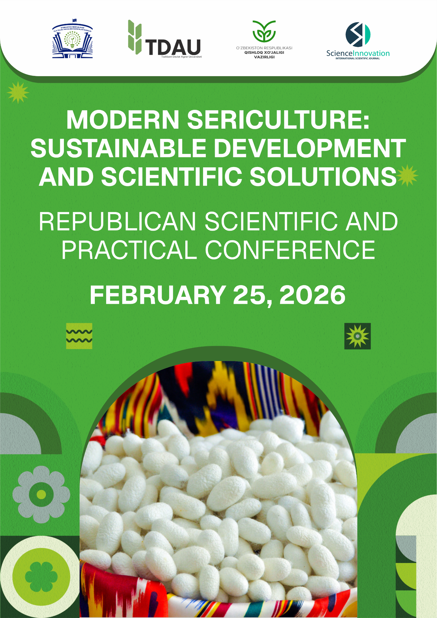
INTERNATIONAL SCIENTIFIC AND PRACTICAL CONFERENCE ON THE TOPIC “MODERN SERICULTURE: SUSTAINABLE DEVELOPMENT AND SCIENTIFIC SOLUTIONS”
INFORMATION LETTER
ABOUT THE CONFERENCE
Pursuant to Clause 9 of the Resolution No. PQ-200 of July 4, 2023, of the President of the Republic of Uzbekistan “On Measures to Effectively Organize Public Administration in the Fields of Higher Education, Science, and Innovation within the Framework of Administrative Reforms,” and in order to ensure the timely and effective organization of international and national scientific conferences, symposiums, seminars, and other scientific and scientific-technical events aimed at expanding the scope of international scientific and technical cooperation, we cordially invite you to participate in the International Scientific and Practical Conference entitled “Modern Sericulture: Sustainable Development and Scientific Solutions,” which will be held on February 25, 2026, in cooperation between Tashkent State Agrarian University and the international scientific journal Science and Innovation

Conference time and place: February 25, 2026, Tashkent State Agrarian university
Official language of the conference: Uzbek, English and Russian.
Conference format: online and offline

CONFERENCE ORGANIZERS
- MINISTRY OF HIGHER EDUCATION, SCIENCE AND INNOVATION
- MINISTRY OF AGRICULTURE OF THE REPUBLIC OF UZBEKISTAN
- TASHKENT STATE AGRARIAN UNIVERSITY
- INTERNATIONAL JOURNAL OF SCIENCE AND INNOVATION

MAIN ASPECTS OF THE CONFERENCE
- Achievements in sericulture breeding and priority directions for modernizing the seed production system
- Technological integration of cocoon raw material preparation and processing of sericulture products
- Application of innovative agrotechnologies in the sustainable development of mulberry cultivation and global environmental challenges
- The strategic importance of the agro-industrial complex in ensuring the economic stability of Uzbekistan

REGISTRATION AND SUBMISSION OF CONFERENCE MATERIALS
Articles for participation in the conference will be accepted by February 20, 2026 via the telegram application +998958636340 @Science_MMM_journal
For each article or abstract, local participants will pay 200,000 soums, and foreign participants will pay 10 US dollars.
Local participants will transfer the specified amount to the account number 5614682038720498 (Raxmatullayeva Gulira'no)
Visa card number for foreign participants:
Visa karta, karta raqami: 4916990300840169
F.I.SH.: BAKHTIYOR RUSTAMOV
Bank: AO "Uzum Bank"
MFO: 01190
Hisob raqami: 2261 8000 9903 5944 1001
After payment is made, you will be required to send a payment receipt.

REQUIREMENTS FOR PREPARATION OF CONFERENCE TEXTS
The content of the problems raised in the article, the description of the research method, the results obtained by the author, the data and conclusions should be short and clear.
Requirements for formalization:
    - Annotation and keywords should be indicated (in three languages);
    - The text of the article should be A4 size, with margins of 2 cm from the top and bottom, 3 cm from the left, and 1.5 cm from the right;
    - The text of the article should be written in the Word text editor, Times New Roman font, size 12, 1.15 spacing and 3-6 pages.

INDEXING OF CONFERENCE MATERIALS
Each article accepted for the conference will be indexed in the European Zenodo and Open Aire, Poland Index Copernicus, international databases and in the Google scholar international search engine.
A separate DOI number is obtained for each article.

ADDRESS OF THE ORGANIZING COMMITTEE

Address: TASHKENT STATE AGRARIAN UNIVERSITY

SAMPLE:
ARTICLE TITLE
Safarova Rokhatoy Gaybullayevna – Student of Tashkent State Agrarian university
Gulyamova Aziza Otabek kizi - Basic doctoral student of Tashkent State Agrarian university
Annotation: text, text, text, text, text.
Keywords: text, text, text, text, text, text
Main text….
List of used literature:
1. Rahmatullayev Sh. Modern literary Uzbek language. "University" publishing house. 2006. – 212 p.
2. Hamrayev M. Linguistic analysis patterns in the subject of mother tongue. “Sharq” NMAK. 2015. – 123 p.

