
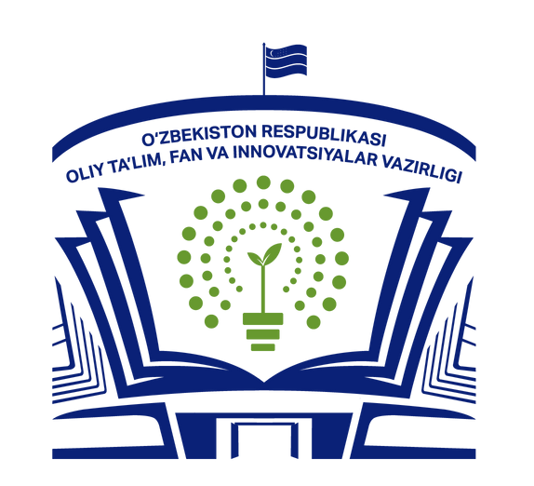


II Republican Scientific and Practical Conference “Women Scientists” entitled “The Role of Forestry and Medicinal Plant Science in Ensuring Ecological Sustainability

March 26, 2026
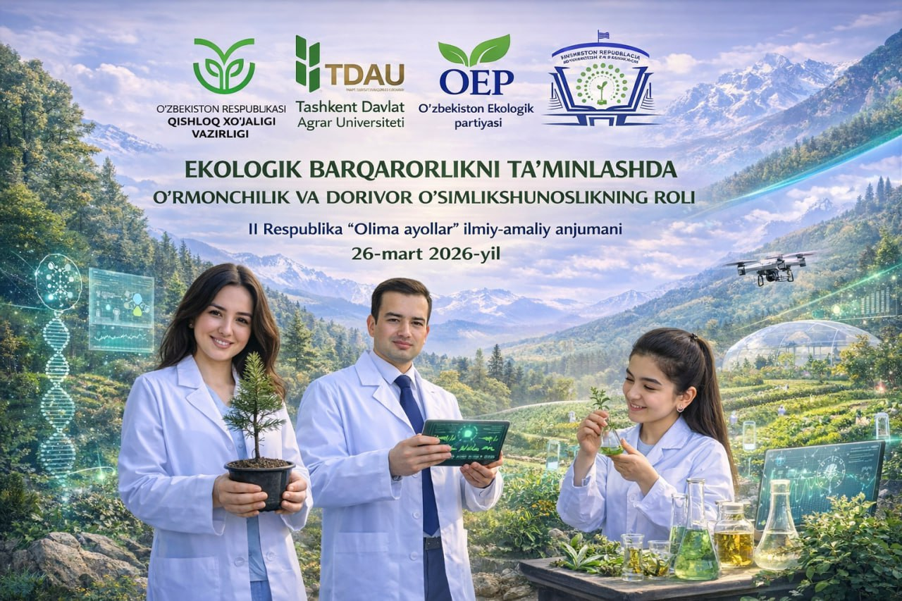

INFORMATION LETTER
II Republican Scientific and Practical Conference
“THE ROLE OF FORESTRY AND MEDICINAL PLANT SCIENCE IN ENSURING ECOLOGICAL SUSTAINABILITY”

In accordance with Order No. 11 of January 16, 2026, issued by the Minister of Higher Education, Science and Innovation of the Republic of Uzbekistan, the plan of international and national scientific and scientific-technical events for 2026 has been approved. In this regard, we cordially invite you to participate in the II Republican Scientific and Practical Conference “Women Scientists” entitled “The Role of Forestry and Medicinal Plant Science in Ensuring Ecological Sustainability,” which will be held on March 26, 2026, at Tashkent State Agrarian University. Research articles will be published in the scientific journal “Bulletin of Agrarian Science of Uzbekistan,” while abstracts will be issued as a conference proceedings collection.
Deadline for paper submission: March 20, 2026
Conference languages: Uzbek, Russian, English

PARTNER ORGANIZATIONS
- Ministry of Higher Education, Science and Innovation of the Republic of Uzbekistan
- Ministry of Agriculture of the Republic of Uzbekistan
- Ministry of Ecology, Environmental Protection and Climate Change of the Republic of Uzbekistan
- Forestry Agency
- Ecological Party of Uzbekistan

MAIN CONFERENCE SECTIONS

SECTION 1. Forestry, Ecology and Forest Protection
SECTION 2. Medicinal Plants and Pharmaceuticals
SECTION 3. Ornamental Horticulture and Urban Greening
SECTION 4. Non-timber Forest Resources, Ecotourism and Economics
SECTION 5. Agronomy, Fruit and Vegetable Production, Storage and Processing of Agricultural Products
SECTION 6. Application of Innovative Machinery and Technologies in Forestry
SECTION 7. Prospects for the Application of Innovative Technologies in Veterinary Science and Livestock Development

REQUIREMENTS FOR CONFERENCE MATERIALS

The content of the issues addressed in the article, the description of the research methodology, the data obtained by the author, and the conclusions must be presented concisely and clearly. The title of the article must fully correspond to its content. Formatting requirements:
- The article must be prepared in IMRAD format in accordance with international standards.
- The title, abstract, and keywords must be provided in Uzbek, Russian, and English (if the article is written in Russian or English, it is sufficient to provide the abstract and keywords in Russian and English).
- Articles must correspond to the scientific journal’s scope, address relevant scientific issues, be based on completed research, and include well-grounded proposals and recommendations.
- The article must be formatted on A4 paper size with the following margins: top and bottom — 2 cm, left — 3 cm, right — 1.5 cm.
- The manuscript must be prepared in Microsoft Word using Times New Roman font, size 11 pt, single line spacing, with a length of 3–4 pages.
- Figures and tables must be numbered; table titles should be centered above the table, and figure captions should be centered below the figure.
- The reference list must be formatted according to the American Psychological Association (APA Style). All cited sources must be included in the reference list. One author may participate in no more than three articles.

SAMPLE

TITLE OF THE REPORT
Valiev Vali Valievich
E-mail address
Academic degree, position held, name of the institution
Abstract
Keywords (no more than 10 words):

Main text. Text, text, text, text [1].

References
- Author. Title of the article or book. Place of publication, year of publication, page number.

The name of the electronic file must consist of the surname of the first author and the section number. For example: Valiev V. Section 2.docx. The file must be saved in doc/docx format.

CONFERENCE PARTICIPATION APPLICATION FORM (SAMPLE):
- Full name (Surname, Name, Patronymic) ________________________________
- Academic degree and academic title __________________________________
- Place of work, position _____________________________________________
- Title of the report (section) ________________________________________
- Phone number _______________________________________________________
- E-mail _____________________________________________________________

ATTENTION!

Applications, articles, and abstracts for participation in the conference will be accepted until March 20, 2026 (inclusive). Conference invitations (Zoom link) will be sent only to registered participants.
The Organizing Committee reserves the right to select and reject reports and articles that do not meet the established requirements and criteria. Articles and abstracts with an originality level below 80% will not be included in the journal or in the conference proceedings.
The Organizing Committee is responsible for reviewing submitted abstracts and articles and for their electronic publication.

MATERIALS WILL BE ACCEPTED STRICTLY IN ACCORDANCE WITH THE REQUIREMENTS SPECIFIED IN THIS LETTER.

- For each article approved by the Editorial Board, a publication fee of 250,000 UZS per article is required.
- For each approved abstract, a fee of 80,000 UZS is required.
- Conference materials must be submitted no later than March 20, 2026, via Telegram to Malokhat Khakimova (+99897404-05-86) @malokhat_xakimova. Payment should be made to the following bank card: 5614 6887 0055 2812 (Malokhat Khakimova). After payment, the receipt must be submitted.

Payment reference: Conference organizational fee.

Conference participants will receive an electronic certificate and an electronic copy of the conference proceedings (sent to the email address provided in the application form).

Organizer’s address: 2 University Street, Qibray District, Tashkent Region, 100700, Uzbekistan.

Conference Coordinator: Faculty of Forestry and Landscape Design, Department of Forestry and Landscape Design.

Contact persons for further information:
Malokhat Khakimova: +99897404-05-86
Shokhista Kholova: +99891005-79-81

